TRYHACKME LAB REPORT

Nmap Basic Port Scans
Internship: DG Interns HUB — Week 2
Domain: Cybersecurity — Network Reconnaissance
Platform: TryHackMe
Room Name: Nmap Basic Port Scans

1. Aim
To understand basic Nmap port-scanning techniques and learn how TCP and UDP responses help identify the state of network ports.

2. Objectives
- Understand the purpose of port scanning.
- Learn TCP SYN and TCP connect scans.
- Understand UDP scanning.
- Identify open, closed and filtered port states.
- Learn how to save Nmap scan results.
- Understand the importance of authorized scanning.

3. Introduction
A port is a logical communication endpoint used by network applications. Port scanning checks selected ports on a target host to determine their state.
Nmap is a free, open-source network discovery and security auditing tool. It helps administrators and security professionals identify exposed services and understand a system's network attack surface.
Examples of commonly used ports include:
- TCP 22 — SSH
- TCP 80 — HTTP
- TCP 443 — HTTPS
- TCP 445 — SMB
- UDP 53 — DNS
These are common uses, not guarantees that a particular service is running.

4. Types of Port Scans

4.1 TCP SYN Scan
Option: -sS
- Sends TCP SYN probes to target ports.
- An open TCP port commonly responds with SYN-ACK.
- A closed TCP port commonly responds with RST.
- A filtered port may not respond or may return an ICMP error.
- Usually does not complete the normal TCP handshake for open ports.
Example:
sudo nmap -sS -p 22,80,443 TARGET_IP

4.2 TCP Connect Scan
Option: -sT
- Uses the operating system's connection API.
- Attempts to establish a full TCP connection.
- Can be used when raw-packet privileges are unavailable.
- May generate connection records in target services.
Example:
nmap -sT -p 22,80,443 TARGET_IP

4.3 UDP Scan
Option: -sU
- Sends UDP probes to selected ports.
- A UDP response can indicate an open port.
- An ICMP port-unreachable response commonly indicates a closed port.
- No response may leave the port classified as open or filtered.
Example:
sudo nmap -sU -p 53,123 TARGET_IP
UDP scans can take longer because UDP services often do not respond to arbitrary probes.

4.4 Scanning Specific Ports
Option: -p
This option selects which ports Nmap scans.
Example:
nmap -p 22,80,443 TARGET_IP
To scan all TCP ports:
nmap -p- TARGET_IP
Use the scope and scan limits specified by your authorized lab.

5. Understanding Port States
Port State | Meaning
Open | An application is accepting connections or responding on the port
Closed | The target is reachable, but no application is listening on the port
Filtered | Nmap cannot determine the port state because packet filtering prevents a clear response
Unfiltered | The port is reachable, but the scan cannot determine whether it is open or closed
Open or filtered | Nmap cannot distinguish an open port from a filtered port
Closed or filtered | Nmap cannot distinguish a closed port from a filtered port

6. TCP Handshake and Scan Behaviour
A normal TCP connection generally uses a three-way handshake:
- Client sends SYN.
- Server responds with SYN-ACK.
- Client sends ACK.
During a typical SYN scan, an open port often responds with SYN-ACK, after which Nmap does not complete the normal connection. A closed port often responds with RST.
During a TCP connect scan, the operating system attempts to complete the TCP connection.
These packet patterns can be examined in Wireshark to understand the difference between scan types.

7. Practical Methodology

Step 1: Open the Room
- Sign in to TryHackMe.
- Open the Nmap Basic Port Scans room.
- Read the instructions and start the required target machine.
- Record the target IP provided by the lab.

Step 2: Perform the Required Scans
Follow the room tasks to practise the scan types it specifies.
Record the actual command, target, port states and important output for each exercise.

Step 3: Interpret the Results
Check:
- Which ports are open or closed.
- Which ports appear filtered.
- Whether the result differs between TCP and UDP.
- Whether the service associated with an open port is identified.
- Whether firewall behaviour may affect the results.

Step 4: Save the Results
Normal text output:
nmap -sS -oN basic_scan.txt TARGET_IP
XML output:
nmap -sS -oX basic_scan.xml TARGET_IP
Replace TARGET_IP with the actual authorized lab target. Save the output files in your Week 2 Captures folder.

8. Results and Findings
Complete this table using your actual lab results.
Scan Type | Ports Tested | Observed Result
TCP SYN scan | [Enter ports] | [Enter results]
TCP connect scan | [Enter ports] | [Enter results]
UDP scan | [Enter ports] | [Enter results]
Service detection, if performed | [Enter ports] | [Enter results]

Key Observations
- TCP and UDP scans use different probe and response behaviours.
- Open ports may expose services that need security review.
- Filtering can prevent Nmap from identifying a definitive port state.
- Scan results depend on target configuration and network conditions.

9. Security Relevance
Port scanning helps administrators identify exposed services and verify that only approved services are accessible.
SOC analysts may investigate:
- A single host probing many destination ports.
- A device scanning multiple internal hosts.
- Repeated SYN packets without completed connections.
- Unexpected scanning of administrative services.
A port scan is not automatically malicious. It may be part of approved vulnerability assessment or network administration.

10. Challenges and Limitations
- Firewalls can affect port-state detection.
- UDP services may not respond to standard probes.
- Large scans can take considerable time.
- Service detection may not identify an exact software version.
- Scanning must remain within the authorized lab scope.
11. Learning Outcomes
- Understand basic TCP and UDP port scanning.
- Recognize SYN scan and connect scan behaviour.
- Interpret common Nmap port states.
- Save scan output in text and XML formats.
- Understand how scan patterns relate to network monitoring.

12. Evidence Checklist
- Screenshot of the TryHackMe room.
- Screenshots of completed task results.
- Actual Nmap commands and output recorded.
- Port-state findings documented.
- Output files saved in the Captures folder.

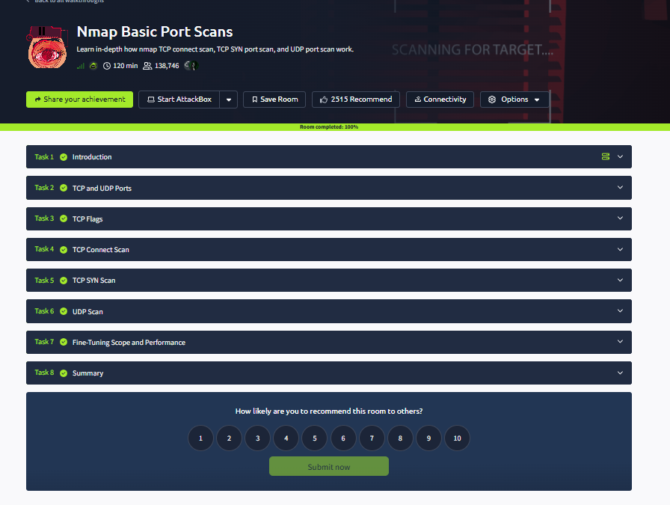

13. Conclusion
The Nmap Basic Port Scans lab introduces methods for identifying the state of network ports using TCP and UDP probes. Understanding the responses helps security professionals assess exposed services and interpret reconnaissance activity in network traffic.

